## **What is the Accelerator Generator and what is its purpose?**

The Accelerator Generator is a tool in the applications tab in the [Dashboard](http://localhost:3000/docs/guides/getting-started/dashboard-and-api-console) that allows you to generate front-end code with the components of your choice. Before the release of this feature, developers were taxed with manually pulling down the [angular-seed](https://github.com/ordercloud-api/angular-seed), filling in the configuration data, and moving component folders into their project. Now you have a head start and can begin customizing your application much faster.

Developers will use the Accelerator UI to select a customized grouping of components as a starting point for their application.

It will also automatically link up the front-end to the back-end based on which app the Accelerator lives on. Once satisfied with your configuration the Accelerator Generator will integrate with GitHub to create a single repository under your profile.

## **How to use the Accelerator?**

In order to create an Accelerator you will need to either be the owner of the organization or a contributor developer with permission to administer applications.

Navigate to the [dashboard](https://dashboard.ordercloud.io/) and click on the **Seller Applications** tab from the left hand nav. Then click on the name of the application you'd' like to create an Accelerator for and you'll see the Accelerator tab at the top.

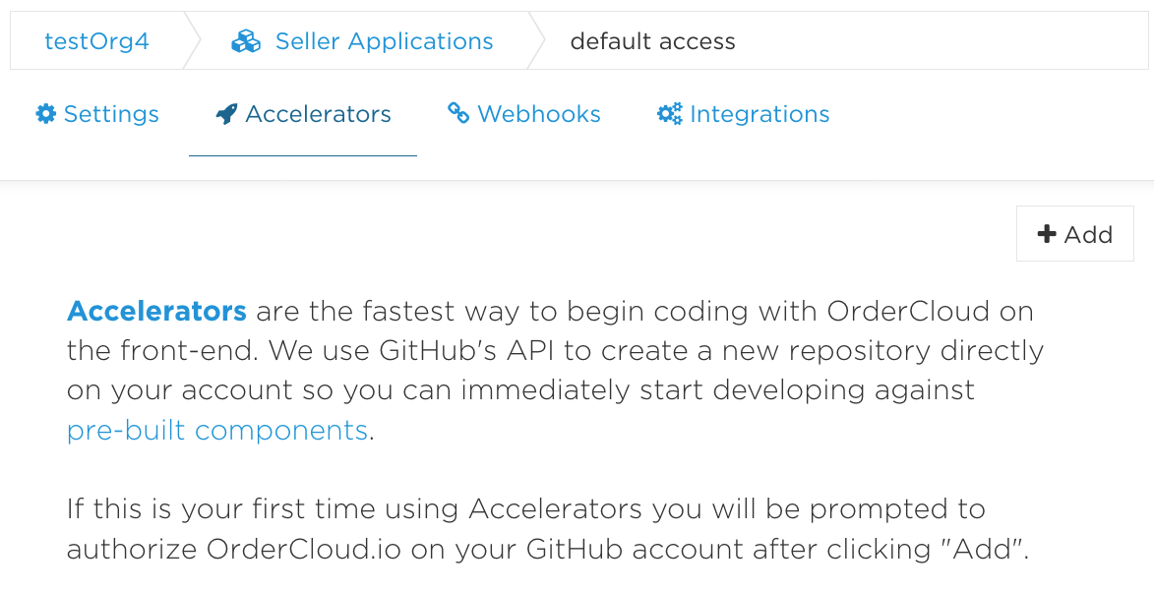

When you click the  **Add** button for the first time, OrderCloud.io will initiate an Oauth handshake with [GitHub](https://github.com/) that will give OrderCloud.io access to manage your public repositories (Note: You will need to disable your pop-up blocker for this to work correctly). After the handshake is successful, you will be routed to the first step of the Accelerator Generator.

Be sure to choose a repository name that does not already exist on your [GitHub](https://github.com/) account. Don't worry if you make a mistake, we'll let you know.

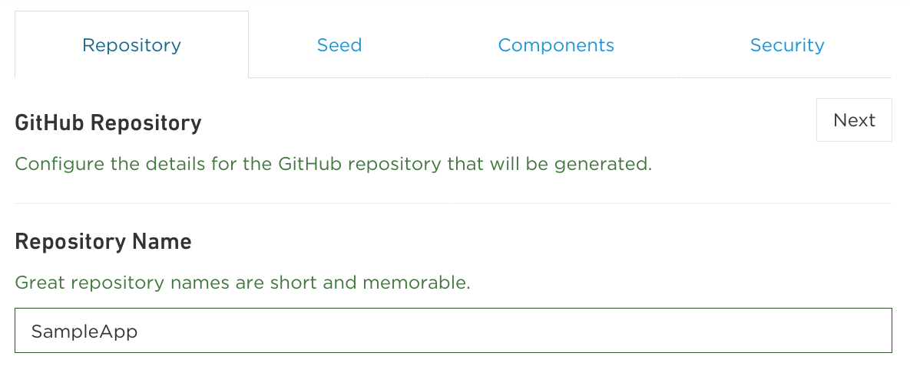

In the next step, select which branch from [angular-seed](https://github.com/ordercloud-api/angular-seed) your accelerator will be generated from. master is selected by default and is the current, stable version.

You are also able to select a theme and color scheme during this step. The Primary Color and Secondary Color will replace [Bootstrap's](http://getbootstrap.com/css/#less-variables) @brand-primary and @brand-secondary variables respectively.

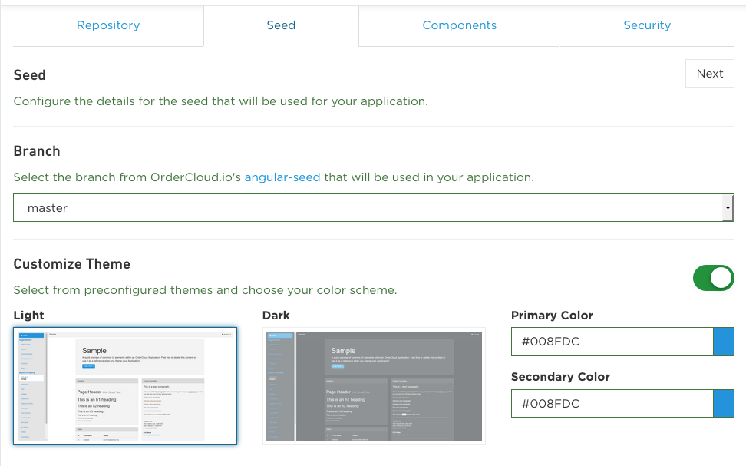

Next, you can pick out which OrderCloud.io Components you would like to see in your application. Each component has a brief description available and can be added by clicking the button. You can also select which branch from OrderCloud.io's [angular-components](http://localhost:3000/) repository the components will be generated from.

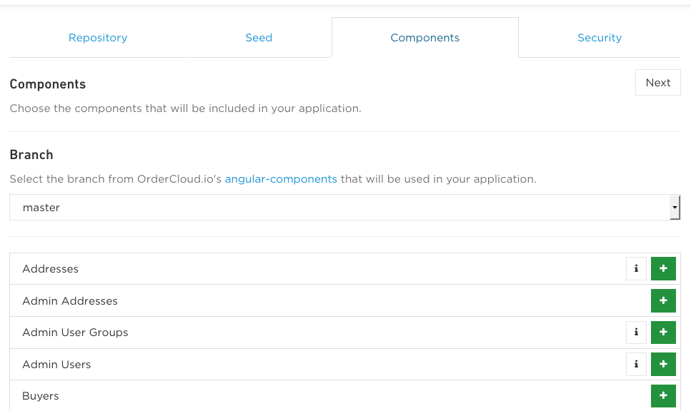

You also have the option to add components from your own GitHub repository. Your component repository should have the same structure as OrderCloud.io's [angular-components](https://github.com/ordercloud-api/angular-components) library and your components should have roughly the [same directory and file structure](https://github.com/ordercloud-api/angular-components/tree/master/addresses). Simply search for your repository under either your own GitHub account or an organization you belong to in order to select your own custom components for your accelerator.

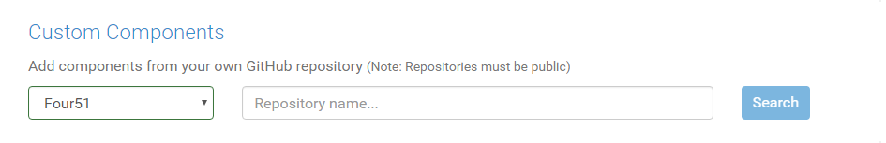

In the last step you will select one or many security profiles for your application. In the screenshot below, you can see we've selected two.The roles for both of these profiles are merged into one list and applied to the application's scope constant upon generation.

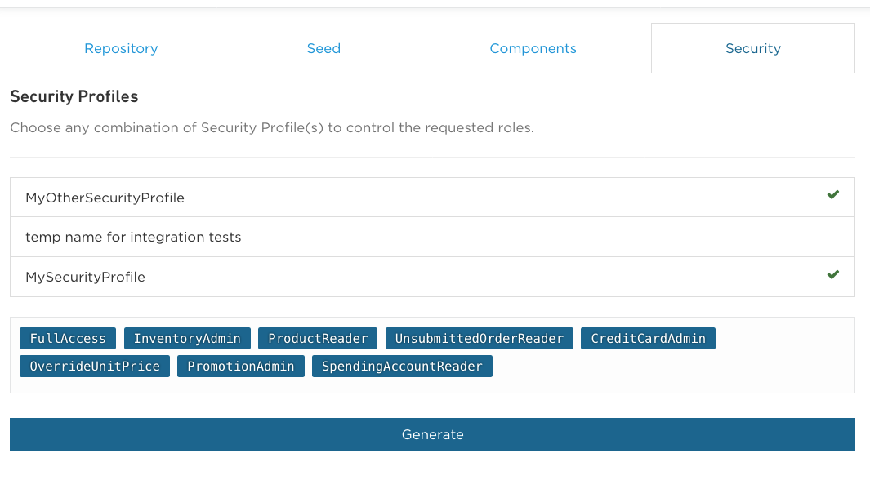

Finally, click Generate. This will grab the Angular Seed, pull in your selected components, create a repository on [GitHub](https://github.com/) under the name you specified, and configure your src/app/app.config.json file. Once the Accelerator Generator is finished, your repository will open in a new tab, ready for you to pull down and start coding.

Navigating back to the Dashboard you should see your newly created accelerator on your application page. If you want, you can delete it from here and OrderCloud.io will remove the repository from your [GitHub](https://github.com/) account. Only the user who created the Accelerator has permission to delete it.

Also, it's worth mentioning this front-end code is deploy-ready for Heroku. [Click Here](http://localhost:3000/docs/angularjs/deployment) for directions on how to deploy your Accelerator app using Heroku.